Communication Skills:
The Importance of Neutrality

Objectives: | To understand the importance of neutrality when working with farmers in participatory research
Time: | 60 mins
Method: | - Read “ Why Neutrality is Important”  - Group discussion  Discussion questions:  - What is neutrality?  - Why is neutrality important in participatory research?  - Exercise

Exercise

Instructions: | - Form groups of three people  - Read the dialogue between farmer and researcher  - Mark with an “X” those passages where the researcher was not neutral  - Discuss the dialogue with your group  Discussion questions:  - How did lack of neutrality influence the researcher’s visit to the farmer?  - What else did you notice about the researcher’s communication style?  - How could the researcher have behaved differently when visiting the farmer?  - Be ready to share your impressions in a group discussion

The farmer (F) is at home. A researcher (R) approaches.

R | Good afternoon, Mrs. Kusye. How are you? I’ve come to see your forage experiment. Can we have a look at your field?
F | Of course, Doctor, let’s go. (F follows R to the plots).
R | (Looks at his notes). Let me see……..we planted these forages last June. They look good, really good.
F | Well, yes, I’ve noticed that this grass . . .
R | (Interrupts). Let’s start with this plot (leads the farmer to the middle plot. Again looks at his notes.). I’m going to write down your opinions on the forages, so just tell me what you think about this plot over here.
F | I don’t like the spacing of these plants.
R | Ahh! You mean they are planted too close? That’s just what Mr. Handoko said! I completely agree with you. I would have recommended a larger spacing had it not been for Mr. Toteng who insisted on this spacing during our planning meeting. I just wanted to avoid trouble, you know .
F | No, in fact I think this can be planted closer.
R | Oh, really? Good, let’s move on to this next plot. Don’t you think this is really good? Look at the foliage. You’ll have a lot of feed for your animals from this. And you’ll have be no problem with uncontrolled grazing. Just look at these plants. The leaves are so high up that no ordinary animal could reach them.
F | Well, Doctor, I don’t really like this species much. It will be a lot of work to cut and carry the feed to my animals. I prefer a low-growing forage that can be grazed here since this field is close to others where I plant my crops.
R | You don’t really want a low-growing plant, Mrs. Kusye because you said during our diagnosis that uncontrolled grazing is a problem. Let’s get on to the third plot, it’s nearly 5 o’clock. What do you think about this plot?
F | It looks good, don’t you think Doctor. Very nice. What do you say?
R | Well, some of these species are really very promising hedgerow species. But, I really have to go now. It’s getting late. Thank you Mrs. Kusye. I really learned a lot from this conversation of ours. I hope I can visit you again next time. Good-bye
F | Good-bye, Doctor. Have a good afternoon.

Why is

neutrality important

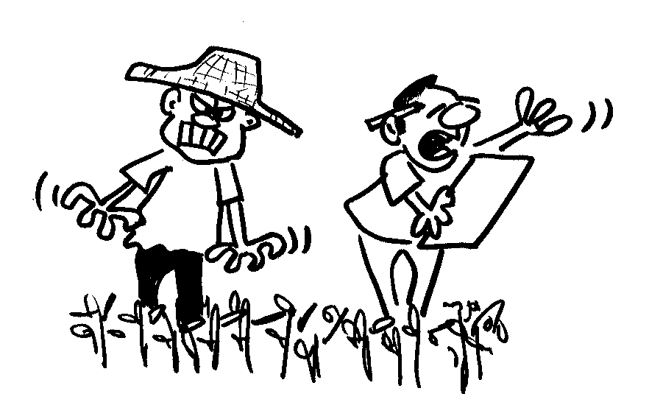
What is neutrality?

All of us have opinions. However, when trying to learn the opinions of others, it is important to avoid expression our own. Doing so may influence what others tell us. Keeping our opinions to ourselves when talking with farmers is called “neutrality.”

Both farmers and researchers have a right to have their own opinions. However, if a researcher wants to find out what the farmer thinks about the issue, then neutrality is essential. Often, farmers want to please researchers by telling them what they want to hear NOT what the farmer really feels about the issue.

It is important that the farmer knows that the researcher really wants to hear his or her opinion. The researcher must respect and value the opinion of the farmer.

How to start an interview?

A good way to start is to pose alternative opinions such as

“I’ve had several interesting discussions with local farmers about this planting system. Some say the plants are too close; others say they could be planted closer. What do you think?”

Such questions are primarily used to warm up the discussion, by reassuring the farmer that his or her point of view (positive or negative) is being sought. Once the farmer is confident enough to take the initiative, the role of the researcher is to listen and to ask open and probing questions.

Researchers should NOT
- lead the conversation
- impose their opinion
- recommend actions
- condition the response of the farmer by asking leading questions

Researchers may give information but NOT their opinion. Being neutral means giving information without giving recommendations.

Some examples of questions that are formulated in a neutral way:

- “I’ve heard a number of interesting opinions from farmers around here about this variety. Some say they like a bushy plant; others say the bushy plant is a problem. I’d like to understand this better. What’s your opinion?”

- “Do you think this might require more or less labor (or capital/fertilizer/irrigation, etc.) than what you would presently use, or the same amount?”

- “How would you market this, or would you use the products mainly for home consumption?”

- “Would you recommend that we continue to test this, or had we better look for a different alternative?”

